80.7528WH
Ken Hahn
6/15/08

Revision 7
6/19/2024
Purpose: Standardize scanning instructions to move material through the system, which prevents losing traceability back to the material certificate.
Scope: All raw material moves from warehouse to staging, staging to press, and press to warehouse.
OVERVIEW
Material handlers shall move materials from staged material to the presses. This is the only location from which material handlers shall pull plastic material. The only exception is material for the purge bin. Staged items are assigned to a press or multiple presses by large press number labels, which are placed directly below the warehouse label. Do not utilize material on a press to which it has not been assigned without checking with the material handler team lead. All IQMS material movement shall happen with the scanner, utilizing either a direct move or a repack. If a material is being physically moved, it needs to be scanned to the new location. The label should match the item's location and quantity on the floor. The only exception is a move to the scale.
When a work order at a press is complete, all materials from that job should be moved to the scale. Only move the items physically; do not scan them to a different location. Also, do not combine any materials that have been repacked together. The warehouse will handle any mergers that need to be done.
Items are tracked through the IQMS system via their serial numbers, so it is crucial that the original serial numbers are preserved during moves and splits. When splitting material, you will need to utilize the scanner's REPACK function to keep the serial numbers linked. Once split, material should not be re-combined. If a replacement or additional label is required, do not print a new one from the computer. Instead, reprint the label from the scanner by performing a label query on the existing label and selecting reprint.
Accuracy is important; use the scale; weigh out material.

Material Prep:
- Material Handler Team Lead will review the Pick Ticket in IQMS Schedule.
- Material Handler Team Lead will retrieve material from the warehouse.
- Any mixing will require a scale and follow the Pick Ticket instructions through IQMS.
- Material Handler Team Lead will stage material for the Material Handlers.
- Material Handlers will review the press schedule in advance of running production to allow the material to be placed in dryer, if necessary, for the production run.

Moving Material from the Warehouse to the Production Floor:

Material Selection
- When raw material is moved out of the warehouse for staging a production run, the material is verified to the Work Order.
- FIFO (First In / First Out) will be followed.

Moving Material
- Find where the material is located which will be listed in IQMS; then physically locate the material in the warehouse. Follow procedures outlined as follows:

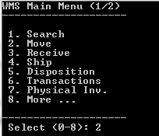
- Type or scan #2 Move
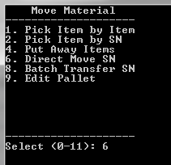
- Type of can #6 Direct Move

- Scan Serial # 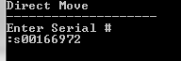
- Scan location 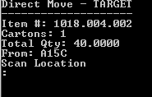
- Scan to the appropriate location, for example, the Press#. Then it will ask you if you want to move it “Y/N?” Choose the appropriate answer.

DIRECT MOVE PROCEDURE:
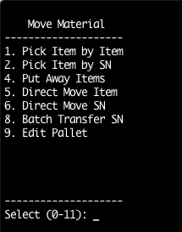
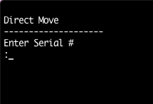
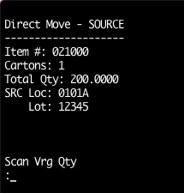
Use when moving 100% of an item from one location to another.
6. Repeat for all materials.

4. Scan the material quantity from the label.
3. Scan the material serial number.
2. Select Direct Move SN (#6).

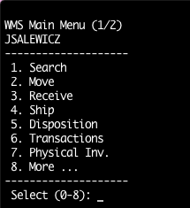
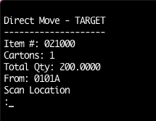
5. Scan the RMSTAGING location from your badge/worksheet.
- Using the scanner start a Move (#2).

REPACK MOVE PROCEDURE:
Use when splitting up item(s) and moving the repack quantity to different location.

A repack allows you to split up an item into smaller quantities. You will typically use this to split material from a gaylord to a barrel or dryer that will be used at a press.

- Place the gaylord or item you are pulling from on the scale, and zero it out.
- Fill the barrel up.
- The scale will display how much was taken out (as a negative).

7. Enter the quantity being repacked out (as shown by the scale). Prefix the number with a “q”. Example: q50
6. Scan the material serial number of the gaylord or item being repacked from.
4. Using the scanner start a Move (#2).

- Select Direct Move SN (#6).

REPACK MOVE PROCEDURE – Continued
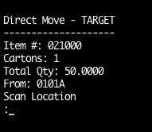
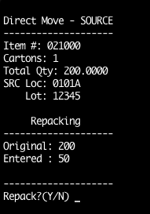
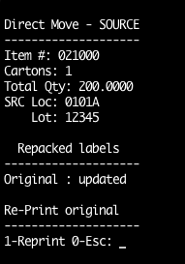
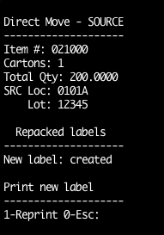
9. The scanner will prompt whether to print the adjusted original label. Enter 1 to print the label. Wait 10 seconds before moving to the next step – (for the label to print).
11. Scan the press barcode from the Material Handler barcode matrix.
8. The scanner will ask if it should repack. Enter y
10. The scanner will prompt whether to print the new repacked label. Enter 1 to print the label.
REPACK MOVE PROCEDURE – Continued

- Place new original label over the old one on – the gaylord or item being repacked from. (The quantity should show the updated total).
- Place the repack label on the container with the repacked quantity. (The label should show the amount taken out of the original container).
- If you need additional labels (ex… for the dryer) follow the LABEL REPRINT INSTRUCTIONS
- Place the gaylord or item back in STAGED MATERIAL and the repacked container at the press.

REPRINT LABEL / LABEL QUERY:
Use for printing an additional or replacement label (dryer tags, etc.), or for querying the label’s status (location, lot no, actual quantity, etc.

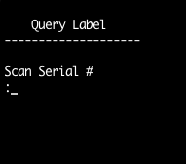
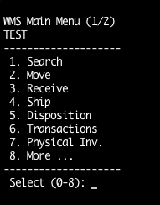
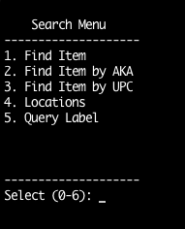
2. Select Query Label (#5)

1. Using the scanner start a Search (#1).

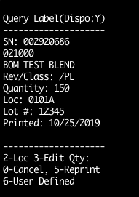
4. The scanner will show the current quantity, location, lot number etc…
To print the label, Enter (#5)

z
3. Scan the label serial number.

5. Enter 1 to confirm.

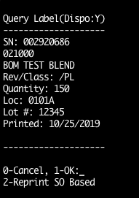

5. Enter 1 to confirm.

MERGING MATERIALS:
Use to merge two separate quantities of an item together. This shall move the material from the first label (source) to the second label (target). The source label will be automatically voided.

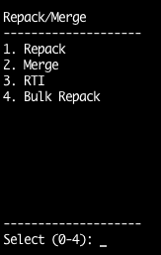

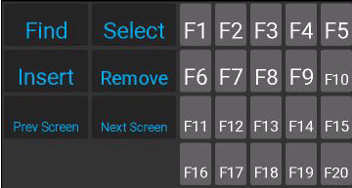
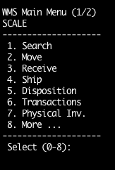
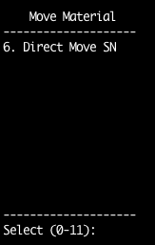
Note: The lot number must be the same for the merge to work.
4. Select Merge (#2)

3. Press the keyboard F2 Key

z
1. Using the scanner start a Move (#2).

2. Select Direct Move SN (#6)

MERGING MATERIALS – Continued

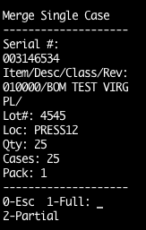

6. Enter (#1) to move the full quantity.

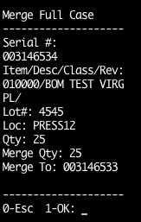
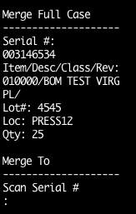
9. Merge is complete. Return to the main menu and use the label query procedure to print the updated target label.

Note: After step 8 - the scanner may prompt to reprint labels or show a FGMulti error message. Ignore these and press enter until you return to the main menu.
8. Enter (#1) to confirm the merge.

5. Scan the serial number from the source label.
7. Scan the serial number from the target label.

Reference Material: N/A

